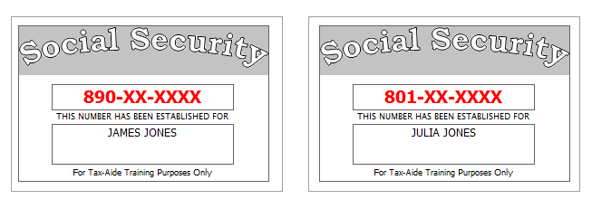
State issued Photo identification is provided for everyone.
James and Julia wish to file Married Filing Jointly.
Jonas meets all requirements to be claimed as their dependent.
Both Julia and Jonas have letters from the IRS with Identity Theft PINs:
- Julia: 102030,
- Jonas: 203040
Looking at last year’s printed return, you notice:
- It was prepared by a professional preparer and only includes copies of forms which were required to be filed with the IRS / NJ Div. of Tax.
- Federal line 13 (Capital Gains) was positive.
- They did not itemize last year.
- $98 was owed to NJ.
- There are no other items that need to be entered on this year’s return.
Contributions to the Gubernatorial Election Campaign Fund should be handled the same way as contributions to the Presidential Election Campaign Fund.
New Jersey Refund / Amount Owed should be handled the same was as their Federal Refund / Amount owed.
Julia is a Veteran from the US Armed Forces.
James and Julia did not have any purchases on which they would owe Use Tax.
They rented an apartment in Pluckemin, NJ all year. Their total rent was $21,000 for the year.
Medical coverage:
- James had Medicare Part A, but not Parts B, C, or D.
- Julia had coverage as part of her retirement plan.
- Jonas had coverage via CHIP

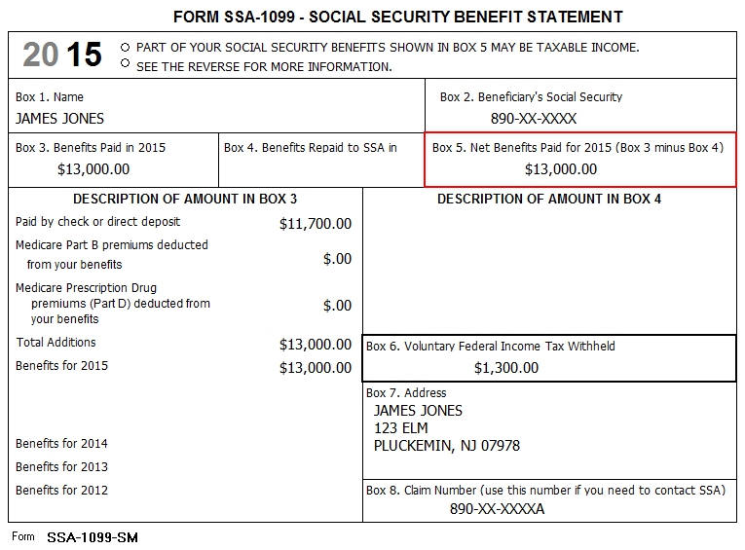

Acme Financial | End of Year Tax Information Statement  Tax Year 2015 • Account 203040506 | Statement Date: 01-30-2016  Page 1 of 1 | 2015
123 Main  P.O. Box 07978-123  Pluckemin, NJ 07978  PAYER’S Federal ID No: 71-9XXXXXX | James Jones  123 Elm  Pluckemin, NJ 07978  RECIPIENT’S ID No: 890-XX-XXXX | Your Broker:  SERGE BRONSKI  888-555-5555  sbronski@rjones.com

FORM 1099-B 2015 Proceeds from Broker and Barter Exchange Transactions
Long-term transactions for which basis is reported to the IRS - Report on form 8949 with Box D checked
1a Description, 2 Long-term, 3 Basis reported to IRS, 6 Net Proceeds
Quantity | 1b Date Acquired | 1c Date Sold | 1d Proceeds | 1e Cost or other Basis | 1f Code | 1g Adj | Gain / Loss(-) | 4 Federal Tax Withheld
Acme Corp (ZACO)
10.000 | 07-02-1999 | 01-15-2015 | 2,000.00 | 3,000.00 |  |  | (1,000.00) | 0.00
10.000 | 07-02-2000 | 03-15-2015 | 2,000.00 | 3,000.00 |  |  | (1,000.00) | 0.00
10.000 | 07-02-2000 | 05-15-2015 | 2,000.00 | 3,000.00 |  |  | (1,000.00) | 0.00
10.000 | 07-02-2000 | 07-15-2015 | 2,000.00 | 3,000.00 |  |  | (1,000.00) | 0.00
10.000 | 07-02-2000 | 09-15-2015 | 2,000.00 | 3,000.00 |  |  | (1,000.00) | 0.00
10.000 | 07-02-2000 | 11-15-2015 | 2,000.00 | 3,000.00 |  |  | (1,000.00) | 0.00
60.000 |  |  | 12,000.00 | 18,000.00 |  | 0.00 | (6,000.00) | 0.00
Acme Inc. (ZAI)
10.000 | 07-02-1999 | 02-15-2015 | 2,000.00 | 3,000.00 |  |  | (1,000.00) | 0.00
10.000 | 07-02-2000 | 04-15-2015 | 2,000.00 | 3,000.00 |  |  | (1,000.00) | 0.00
10.000 | 07-02-2000 | 06-15-2015 | 2,000.00 | 3,000.00 |  |  | (1,000.00) | 0.00
10.000 | 07-02-2000 | 08-15-2015 | 2,000.00 | 3,000.00 |  |  | (1,000.00) | 0.00
10.000 | 07-02-2000 | 10-15-2015 | 2,000.00 | 3,000.00 |  |  | (1,000.00) | 0.00
10.000 | 07-02-2000 | 12-15-2015 | 2,000.00 | 3,000.00 |  |  | (1,000.00) | 0.00
60.000 |  |  | 12,000.00 | 18,000.00 |  | 0.00 | (6,000.00) | 0.00
Acme Ltd (ZALTD)
30.000 | 07-02-2004 | 03-15-2015 | 3,200.00 | 3,000.00 |  |  | 200.00 | 0.00
30.000 |  |  | 3,200.00 | 3,000.00 |  | 0.00 | 200.00 | 0.00
Totals |  |  | 27,200.00 | 39,000.00 |  | 0.00 | (11,800.00) | 0.00

FORM 1099-B 2015 Proceeds from Broker and Barter Exchange Transactions
Long-term transactions for which basis is NOT reported to the IRS - Report on form 8949 with Box E checked
1a Description, 2 Long-term, 3 Basis reported to IRS, 6 Net Proceeds
Quantity | 1b Date Acquired | 1c Date Sold | 1d Proceeds | 1e Cost or other Basis | 1f Code | 1g Adj | Gain / Loss(-) | 4 Federal Tax Withheld
Acme Ltd (ZALTD)
30.000 | 07-02-2005 | 08-15-2015 | 2,900.00 | 3,000.00 |  |  | (100.00) | 0.00
30.000 | 07-02-2005 | 10-15-2015 | 2,900.00 | 3,000.00 |  |  | (100.00) | 0.00
30.000 |  |  | 5,800.00 | 6,000.00 |  | 0.00 | (200.00) | 0.00
Totals |  |  | 5,800.00 | 6,000.00 |  | 0.00 | (200.00) | 0.00

Acme Financial | End of Year Tax Information Statement  Tax Year 2015 • Account 203040506 | Statement Date: 01-30-2016  Page 1 of 1 | 2015
123 Main  P.O. Box 07978-123  Pluckemin, NJ 07978  PAYER’S Federal ID No: 71-9XXXXXX | Julia Jones  123 Elm  Pluckemin, NJ 07978  RECIPIENT’S ID No: 801-XX-XXXX | Your Broker:  SERGE BRONSKI  888-555-5555  sbronski@rjones.com

FORM 1099-B 2015 Proceeds from Broker and Barter Exchange Transactions
Long-term transactions for which basis is reported to the IRS - Report on form 8949 with Box D checked
1a Description, 2 Long-term, 3 Basis reported to IRS, 6 Net Proceeds
Quantity | 1b Date Acquired | 1c Date Sold | 1d Proceeds | 1e Cost or other Basis | 1f Code | 1g Adj | Gain / Loss(-) | 4 Federal Tax Withheld
Acme et Cie (ZAEC)
10.000 | 07-02-1999 | 01-15-2015 | 2,000.00 | 3,002.00 |  |  | (1,002.00) | 0.00
10.000 | 07-02-2000 | 03-15-2015 | 2,000.00 | 1,000.00 |  |  | 1,000.00 | 0.00
60.000 |  |  | 4,000.00 | 4,002.00 |  | 0.00 | (2.00) | 0.00
Totals |  |  | 4.000.00 | 4,002.00 |  | 0.00 | (2.00) | 0.00

Julia had her own account at the same brokerage as James.

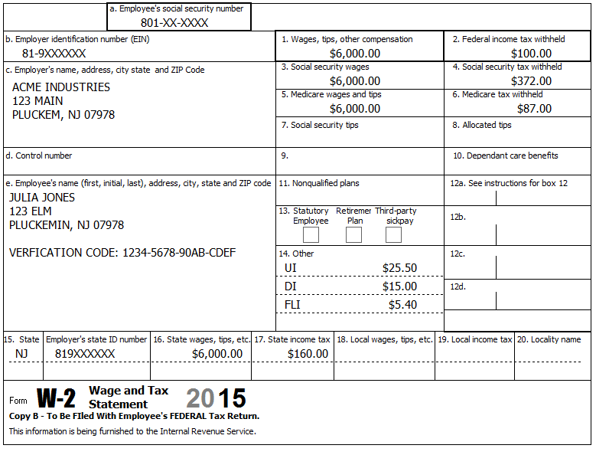
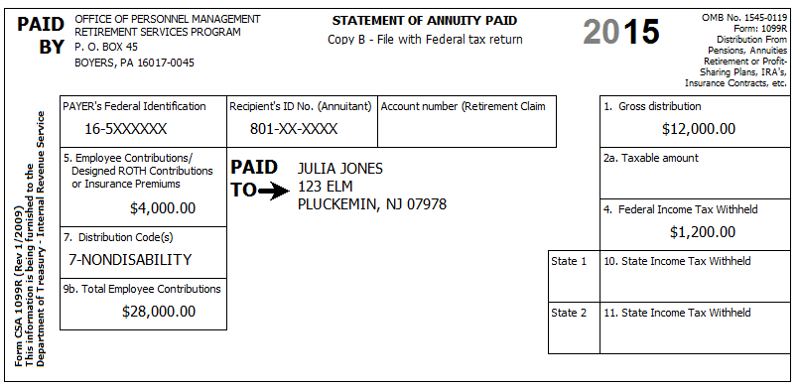
Julia started receiving her pension on May 1, 2013. It is setup as a joint and survivor annuity.

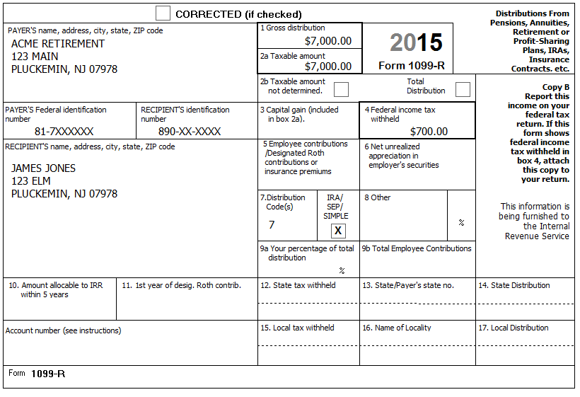
TP has no information on contributions to this IRA.
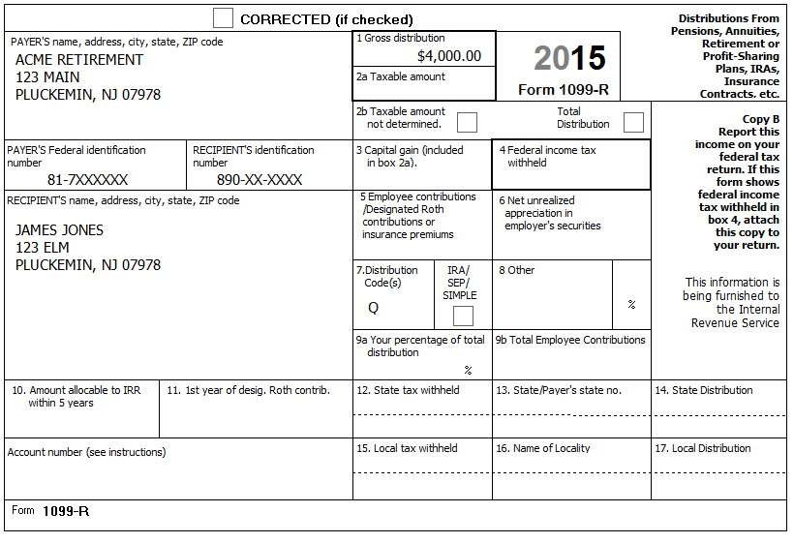
TP has no information on contributions to this IRA.
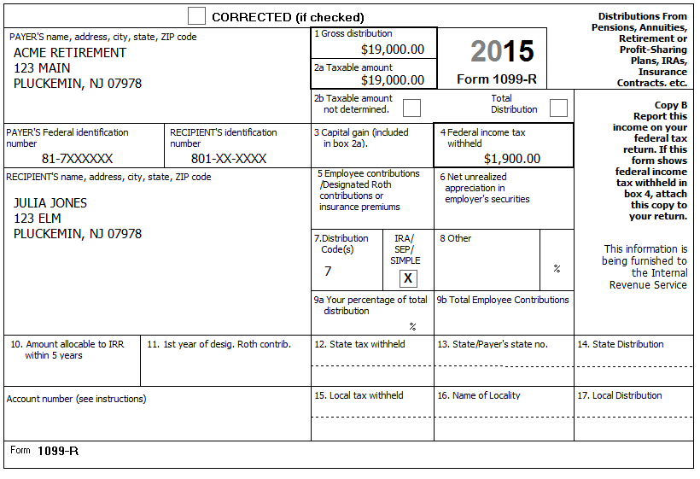
TP has no information on contributions to this IRA.
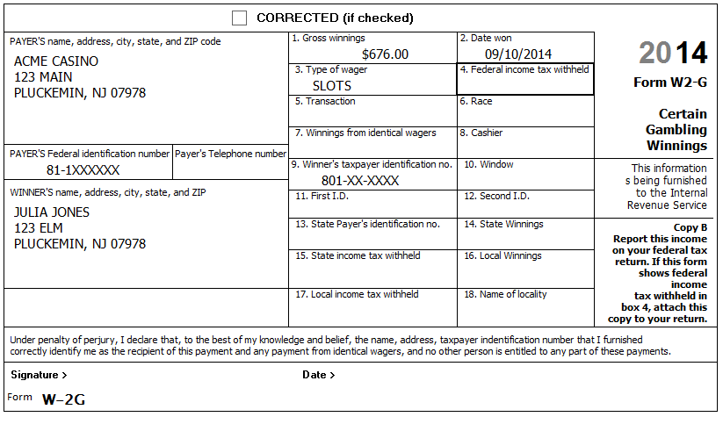

Check your results:
- Be sure to run diagnostics and create the e-file to make sure TW is happy.
- Every line on the Federal 1040, Federal Sch A, and NJ 1040 should match exactly.
Discussion Questions:
- How did you determine amount to use for Office of Personnel Management (CSA-1099), Simplified Method, line 5?
- How did you find Municipality code to use on NJ 1040 Pg1?
- How would you verify that the NJ amount owed shown on their prior year return was not changed after return printed (and that it was actually paid)?
- Assuming there is no carry-forward next year, but the TP remembers to bring the complete file (including the printed return) with them, what would you highlight for next year’s preparer?
- If NJ 1040 lines 37a and 38 have amounts, why are lines 37b and 37c blank?
- How would you check that they are entitled to use their rent on NJ Wkt F? (i.e. Check that their rental unit meets all requirements listed in the NJ 1040 Instructions.)
- NJ 3 Year rule
  - Is it possible for TP to change his mind and choose to use NJ 3 year rule retroactively?
  - How would NJ 1040 lines be adjusted if NJ 3 year had been used
  - Answer above (a) and (b) if TP started pension in TY2012 instead of TY2013?
- Is TP required to calculate and take Required Minimum Distribution (RMD) for 2015?
  - Assume return being prepared in mid-February…
  - Reminder – Distributions:
    - TP regular IRA = $7,000
    - TP Roth IRA = $4,000
    - SP regular IRA = $19,000
  - What, if anything, to do if RMD=$12,000?
  - What, if anything, to do if RMD=$9,000?
  - What, if anything, to do if RMD=$5,000?
  - What, if anything, to do if TP also has 2nd regular IRA from which nothing was withdrawn and 1st regular IRA RMD=$5,000 and 2nd regular IRA RMD=$1,000?
- Assume TP is home owner instead of renter:
  - Already in PTR program, what do you need to prepare this return / what can you lookup if PTR-2 for this year not available yet?
  - Does their 2015 income allow them to continue to qualify?
  - If not in PTR program, how many years can they go back to establish the best base year amount (assuming property tax has going up each year and TP meets requirements each year)?
- W-2 Verification code – Do you need to it fill in?
- Do we need to enter anything in new Identity Verification section of Main Info (below E-File PIN entry)

